**The aquatic breathing strategy sustains elevated basal metabolic rates in aquatic mammals**

1He, R.S., 3De Ruiter, S., 1Westover, T., 2Somarelli, J.A., 1, 2 Blawas, A., 1Dayanidhi, D.L., 3Singh, A., 3Steves, B., 3Driesinga, S., 4Halsey, L.G., 5,*6*Fahlman, A.*

1Nicholas School of the Environment, Duke University Marine Laboratory, Beaufort, NC 28516, USA

2Department of Medicine, Duke University Medical Center, Durham, NC 27710, USA

3Department of Mathematics and Statistics, Calvin University, 3201 Burton SE, Grand Rapids, Michigan 49546, USA

4School of Life and Health Sciences, University of Roehampton, London, UK

5Fundación Oceanogràfic de la Comunitat Valenciana, Gran Vía Marqués del Turia 19, 46005 Valencia. Spain.

6Global Diving Research, Inc. Ottawa, K2J 5E8 *ON, Canada.*

*Corresponding author e-mail: afahlman@whoi.edu

**Running title:** Allometric scaling of BMR

**Keywords:** basal metabolic rate, allometric scaling, body mass, heart rate, stroke volume, breathing frequency, tidal volume, cardiac output, minute ventilation, marine mammal, terrestrial mammal, endotherm

**Abstract:** The literature is still unclear about whether BMR differs systematically between terrestrial and aquatic taxa, and, if so, how the cardiorespiratory system functions to support these differences. To address this, we performed a comparative analysis of BMR across 722 mammalian species showing that aquatic mammals have elevated BMRs compared to terrestrial mammals. We then hypothesized that, to provide elevated tissue oxygen (O2) to support their higher BMRs, aquatic mammals would have a higher delivery of O2 through the cardiorespiratory system. Although the minute ventilation and cardiac output of aquatic mammals was not elevated relative to terrestrial mammals, we calculated that the breathing strategy exhibited by the former, characterised by a lower breathing frequency and higher tidal volume, results in elevated alveolar ventilation – a more accurate measure of effective gas exchange. Moreover, aquatic mammals have higher blood hemoglobin concentrations giving them a higher O2 loading capacity, which may be an alternative mechanism to a higher cardiac output for supporting their increased BMR. The physiological phenotypes of aquatic species provide valuable models to better understand how different groups of mammals across a wide range of sizes and from diverse environments maintain metabolic homeostasis.

**Introduction**

Basal metabolic rate (BMR) is a fundamental metric in comparative physiology that describes a standardized unit of energy flow which can be used to compare the baseline energetic requirements of organisms and understand how changes in an organism’s environment affect its metabolism (Kleiber, 1961). It is well known that BMR scales with body mass (*M*) as *BMR = cMn* , where *n* is the allometric mass-exponent, and *c* a constant. There continues to be considerable controversy over the value of the allometric mass-exponent (Benedict and Ritzman, 1935; Darveau et al., 2002; Kleiber, 1947; Rubner, 1865; West et al., 2002; White, 2010), but values between 0.67 to 0.75 have been the most commonly cited, and a number of theoretical models have been developed to justify their existence (Darveau et al., 2002; West et al., 1997; West et al., 2002; White and Seymour, 2003). However, there are also studies that argue there is no single universal mass-exponent that encompasses all species (Darveau et al., 2002; Kolokotrones et al., 2010; White, 2010), or that diet, ambient temperature and phylogeny may alter the relationship between body mass and BMR, thereby increasing variability of measured mass-exponents (McNab, 1988, 2008; Naya et al., 2018; Upham et al., 2019).

A number of studies have measured BMR in marine mammals and concluded that these semi- and fully aquatic species have higher metabolic requirements than terrestrial mammals (Hart et al., 1959; Irving and Hart, 1957; Irving et al., 1941; Irving et al., 1935; Kanwisher and Sundness, 1965; Kanwisher and Ridgway, 1983; Scholander, 1940; Scholander et al., 1942; Scholander et al., 1950; Sergeant, 1973; Snyder, 1983; South et al., 1976; Williams et al., 2001). However, several studies have opposed this view and presented data that suggest the BMR of marine mammals is not elevated (Gallivan and Ronald, 1979; Lavigne et al., 1986; Pedersen et al., 2020; Rosen and Trites, 2013; Schmitz and Lavigne, 1984; Worthy et al., 2013). There are a number of potential reasons for this discrepancy. First, BMR is a standardized unit defined under strict conditions to allow for accurate comparisons between species. For example, BMR should be measured in an organism’s thermoneutral zone (TNZ), but a TNZ has not been determined for many marine species (Rosen and Trites, 2014), and it is therefore unclear which studies provide true estimates of BMR. In one study which adhered to the strict conditions for BMR, the authors could not reject the hypothesis that BMR is the same for terrestrial and marine mammals (Lavigne et al., 1986).

Second, heteroscedasticity, or non-constant variance of regression residuals, could influence analyses of the scaling of BMR. Heteroscedasticity, can be seen in the ‘mouse to elephant’ scatter plot/regression in a number of studies investigating metabolic scaling. For example, Figure 5 in White et al. (White, 2010) and Figure 1a in Kolokotrones et al. (2010) demonstrates that the best fit regression line underestimates measured BMR for body mass of 10 kg. Given that all marine mammals are larger than 10 kg, BMR may appear elevated. A past study tried to account for this anomaly by using a quadratic equation to estimate the allometric relationship in terrestrial mammals (Kolokotrones et al., 2010). However, the quadratic model becomes isometric for body masses above approximately 700 kg, which suggests that the BMR of a blue whale (190 tonne) would be 388% higher than that estimated from the equation by Kleiber.

We address this issue with a robust analysis of one of the largest datasets assembled on BMR in mammals that includes phylogenetic information to account for species relatedness. We hypothesized that if BMR differs between terrestrial and marine (or aquatic) mammals, the delivery of O2 should scale similarly for minute ventilation and cardiac output, the products of *V*T x *f*R, and *f*H x SV, respectively. Thus, if BMR is greater in aquatic mammals, both the effective ventilation and the volume of O2 pumped out by the heart should also be greater (Fig. 1), providing further evidence of elevated BMR. Specifically, we hypothesize that: 1) BMR is higher in aquatic mammals than terrestrial mammals (Fig. 1), and in addition, this higher BMR is supported by 2) an elevated delivery of O2 through the cardiorespiratory system (Fig. 1).

In the field of comparative energetics, there remains a controversy as to whether aquatic mammals have higher basal metabolic rates (BMR) than terrestrial mammals. One reason that we might expect aquatic mammals to have elevated BMRs is based on a prediction arising from the heat dissipation limit (HDL) theory. In 2010, Speakman and Król introduced the HDL theory, which proposes that endotherms are often not limited by their ability to access food and convert it into energy as is typically assumed, but rather that metabolic rate is limited by an endotherm’s capacity to remove heat (Speakman and Król, 2010). Because water has a higher thermal capacity than air, aquatic mammals can potentially dissipate heat more effectively than terrestrial mammals. This would result in a lower maximal metabolic rate in terrestrial species and may explain the elevated field metabolic rates of aquatic species (Figure 5 in Speakman et al., 2004)). In turn, terrestrial mammals may have evolved lower BMRs in response to having relatively low maximal metabolic rates, in order to maintain a suitably large aerobic scope, and/or aquatic species may have higher BMRs because of the greater physical and physiological machinery needed to support their high field metabolic rates (Killen et al., 2016) Indeed, some studies have reported higher BMRs in aquatic mammals (Hart et al., 1959; Irving and Hart, 1957; Irving et al., 1941; Irving et al., 1935; Kanwisher and Sundness, 1965; Kanwisher and Ridgway, 1983; Scholander, 1940; Scholander et al., 1942; Scholander et al., 1950; Sergeant, 1973; Snyder, 1983; South et al., 1976; Williams et al., 2001), although others have not (Gallivan and Ronald, 1979; Lavigne et al., 1986; Pedersen et al., 2020; Rosen and Trites, 2013; Schmitz and Lavigne, 1984; Worthy et al., 2013).

All previous studies on the topic can be criticized regarding limitations to the data used and/or analyses employed, which could either generate false differences or mask true differences.

First, while BMR is a standardized measurement that must be recorded while the mammal is within their thermoneutral zone, a putative thermoneutral zone has not been determined for many aquatic species (Rosen and Trites, 2014), and thus many supposed measures of BMR in aquatic mammals may be spurious overestimates. Therefore, in the case of aquatic mammals there may only be a limited number of studies that provide a true BMR estimate, and the resting metabolic rate could be an alternative measure to use. Second, no previous studies have accounted for phylogeny, thus violating a key assumption of regression analyses that the data points are independent. Third, there appears to be variation in the relationship for mammals of larger size (McNab, 2008) resulting in heteroscedasticity (see Fig. 1 in Kolokotrones et al., 2010).

We address this issue with a robust analysis of one of the largest datasets assembled on BMR in mammals that includes phylogenetic information to account for species relatedness. Moreover, we further interrogate the literature on cardiorespiratory parameters to investigate the physiological means by which aquatic mammals service a high field metabolic rate and a putatively high BMR. Specifically, we hypothesize that: 1) BMR is higher in aquatic mammals than terrestrial mammals (Fig. 1), and in addition, this higher BMR is supported by 2) an elevated delivery of O2 through the cardiorespiratory system (Fig. 1).

**Materials and Methods**

As the objective was to compare aquatic and terrestrial mammals, all data obtained were from species with a body mass of 10 kg, representing the body mass of the smallest aquatic mammal, and less than

*Basal metabolic rate*

4320previously published datasets (Genoud et al., 2018; McNab, 2008; White and Seymour, 2003; White and Seymour, 2005), and previous publications F or publicationbody mass and The criteria for measuring BMR included mammals that were inactive adults in a postabsorptive and nonreproductive state, measured under thermoneutral conditions (Kleiber, 1961), and mammals living in aquatic environments had measurements taken in the water. We aimed to only include data for which all criteria for BMR were followed, but for some species this could not be assured, .e.g. the thermoneutral zone is only known for a few number of aquatic species (see Table 2). We therefore include the reported criteria in the supplementary material based on the primary source. Mammals were categorized as terrestrial or marine/aquatic. We hereafter use the term aquatic rather than marine mammal, as not all species included in the definition are defined as marine mammals (cetaceans, pinnipeds, sirenians, marine fissipeds), such as the beaver and muskrat. We restricted mammals over a similar body mass range from 10 kg (smallest aquatic mammal) to 5318 kg (largest aquatic mammal). We therefore exclude a large number of smaller terrestrial mammals which have been used in previous studies.

*Cardiorespiratory variables*

We collected previously published data for heart rate (*f*H), stroke volume (SV), tidal volume (*V*T)and breathing frequency (*f*R)measured on inactive, awake, adult mammals (Table 1). The number of species included in each group and the average body mass of each of those species are summarized in Table 1. We regressed each of these cardiorespiratory variables against body mass for mammals from 11 kg up to 6,650 kg. Juvenile data were included in the dataset but not in the statistical analyses.

*Estimating cardiac output and minute ventilation*

We used the results from the regression equations of *V*T, *f*R, *f*H and SV and a parametric bootstrap to obtain predictions with uncertainty estimates of cardiac output (CO = SV • *f*H) and respiratory minute ventilation (MV = *V*T • *f*R) for aquatic and terrestrial mammals (and the difference between aquatic and terrestrial species) for the body mass range of the data. Briefly, we used function predict.glmmTMB from the glmmTMB R package (Brooks et al., 2017), and function bootMer from the lme4 R package (Bates et al., 2015) to predict 100 parametric bootstrap predictions of *V*T, *f*R, *f*H and SV for each species in the datasets, incorporating uncertainty in model parameter estimates and random effects of order, genus and species; the parametric bootstrap samples were multiplied to estimate cardiac output (CO = SV • *f*H) and minute ventilation (MV = *V*T • *f*R) and the results used to obtain estimated predicted values with percentile-based 95% confidence intervals (see [supplementary materials](https://stacyderuiter.github.io/mammal-allometry/) [section 6](https://stacyderuiter.github.io/mammal-allometry/supplement.html#6_Additional_Predictions_(Derived_Quantities)) for code details). We followed a similar procedure to obtain estimates and confidence intervals for the expected *difference* in cardiac output and minute ventilation for hypothetical species of varying masses differing only in habitat (aquatic vs. terrestrial). Population-level predictions were used for these differences (neglecting all random effects; see [supplementary materials](https://stacyderuiter.github.io/mammal-allometry/) [section 7](https://stacyderuiter.github.io/mammal-allometry/supplement.html#7_Additional_Predictions_(Difference_in_Derived_Quantities_by_Habitat)) for code details).

*Statistical analysis*

The allometric relationships between dependent variables (BMR, *f*H, *f*R, *V*T, and VT) and the independent variables body mass and habitat [aquatic/terrestrial] were analyzed using a general linear mixed-effects (GLM) model with nested random effects of family and order. Models were fitted in R statistical computing software (R Core Team, 2021; RStudio Team, 2021) using the nlme package (Pinheiro et al., 2021); all code and data files are included in the [supplementary materials](https://stacyderuiter.github.io/mammal-allometry/). For all analyses, BMR (kcal day-1), *f*H (beats • min-1), *f*R (breaths • min-1), *V*T (mL) and body mass (kg) were transformed using the base 10 logarithm (log10). Models included an interaction between habitat and body mass, to determine whether there were differences in slopes or intercepts. For each model, following several standard model assessment checks, a type II ANOVA was performed to estimate the contributions of each predictor.

**Results**

The GLM approach was used, which included phylogenetic information and provided taxon-specific predictions. Predictions from the fitted GLM compared favorably with the observed data (see sections 1-5 in [supplementary material](https://stacyderuiter.github.io/mammal-allometry/)).

*Basal metabolic rate*

both the s (terrestrial = 1.48; aquatic = 2.03) and (terrestrial = 0.83; aquatic = 0.66) BMR that was 140% 10 kg but 17% lower at 5000kg

*Heart rate and stroke volume*

There were no significant differences between terrestrial and aquatic mammals in the scaling of either heart rate (*f*H) (Fig. 2) or stroke volume (SV) (Table 2, Fig.).

*Breathing frequency and tidal volume*

The slopes for breathing frequency(*f*R) scaled or tidal volume (*V*T) were not significantly different between aquatic and terrestrial mammals (Table 2, Fig. ). The intercepts for terrestrial as compared with aquatic mammals, on the other hand, was significantly higher (terrestrial: 1.62; aquatic: 1.14) and lower (terrestrial: 1.25; aquatic: 1.66) for *f*R and *V*T, respectively (Table 2). This resulted in a 67% higher *f*R and 202% lower *V*T in terrestrial as compared with aquatic mammals across a body mass from 10 kg to 5000 kg. (Table 2, Fig.).

*Estimating minute ventilation, alveolar ventilation, cardiac output, and cardiac O2 output*

There were no differences between aquatic and terrestrial mammals in terms of estimated cardiac output; however, minute ventilation was different, with expected minute ventilation being lower in terrestrial mammals than aquatic mammals in smaller species (< 100 kg) and higher in terrestrial mammals than aquatic mammals in larger species (see figures S7.1, S7.2, S7.5 and S7.6 for estimated cardiac output and minute ventilation in [section 7](https://stacyderuiter.github.io/mammal-allometry/supplement.html#7_Additional_Predictions_(Difference_in_Derived_Quantities_by_Habitat)) in [supplementary material](https://stacyderuiter.github.io/mammal-allometry/)).

**Discussion**

In support of the hypothesis that aquatic mammals have higher BMRs, our analyses indicate that BMR is 78% higher in aquatic mammals than terrestrial mammals (Fig. 2). This increase in BMR in aquatic mammals is likely to be associated with elevated delivery of O2 through the cardiorespiratory system. We investigated physiological mechanisms by which a heightened oxygen delivery to the cells during rest might be achieved in aquatic species (Fig. 1).

**What supports elevated BMR in aquatic mammals?**

Our analyses suggest that, despite their elevated BMR, aquatic mammals have neither an elevated heart rate (*f*H ) nor stroke volume (SV) at rest (Table 1, Figs. 2B-C). Moreover, the breathing frequency (*f*R) of aquatic mammals is lower than that of terrestrial mammals (Table 2, Fig. 2D), and the lower *f*R has been proposed to help regulate buoyancy rather than having a respiratory function (Mortola, 2015). Tidal volume (*V*T), on the other hand, is higher in aquatic species (Table 2, Fig. 2E), in agreement with previous reports (Fahlman et al., 2017; Piscitelli et al., 2013). Consequently, estimated minute ventilation, which is often used as a measure of ventilatory capacity, varied between terrestrial and aquatic mammals, and was higher in small aquatic mammals than small terrestrial mammals, but lower in large aquatic mammals compared to large terrestrial ones (Table 2, see results in section 6 and 7 in [supplementary material](https://stacyderuiter.github.io/mammal-allometry/)). Thus, increased O2 delivery to support the higher BMR in aquatic mammals is not achieved by elevated cardiac output, while minute ventilation changes in complex ways (Fig. 1).

What other aspects of the cardio-respiratory system, then, could enhance the oxygen cascade in aquatic mammals? (Fig. 1). Alveolar ventilation () accounts for dead space ventilation and consequently is a more accurate reflection of effective ventilation than is minute ventilation. The breathing strategy of aquatic mammals, characterised by a high *V*Tand low *f*R, could therefore result in higher for the same minute ventilation. To explore this, we used the allometric equations for *V*T and *f*R (Table 2) to calculate alveolar minute ventilation () for a range of body masses from 10 to 10,000 kg as:

= (*V*T - *V*D) • *f*R-1 Eq. 1

assuming that the respiratory dead space volume (*V*D) is 7 and 3% of total lung capacity for aquatic and terrestrial mammals, respectively (Kooyman, 1973). Based on these calculations, alveolar ventilation scaled non-linearly, and the equation for an aquatic mammal was:

(L • min-1) = 1.07 • body mass0.52 Eq. 2

while for a terrestrial mammal the equation was

(L • min-1) = 0.21 • body mass0.73 Eq. 3

We know that aquatic mammals have greater blood O2 loading capacity as an adaptation to increase their blood O2 stores during diving (Beechler et al., 2009; Choy et al., 2019; Vestweber et al., 1991). Thus, the same volume of blood ejected from the heart would contain more O2 in an aquatic than a terrestrial mammal. We calculated cardiac O2 output (, L O2 • min-1) as:

(L O2 • min-1) = *f*H • SV • Hb • 1.34 • 0.01 Eq. 4

where *f*H and SV was calculated using the prediction equations in Table 2, and Hb was either the published hemoglobin concentration for a beluga (23 g • dl-1,(Choy et al., 2019) or the average hemoglobin concentration (12.6 g • dl-1) for a horse (15.5 g g • dl-1) (Plotka et al., 1988) and cow (9.6 g • dl-1) (Rusoff et al., 1951); 1.34 is the O2 loading capacity (ml O2 per g) of hemoglobin. Based on these calculations, the estimated and for a 200 kg aquatic mammal are 49 and 64% higher, respectively, than for a terrestrial mammal.

Combining our analyses with information in the literature suggests that the aquatic breathing strategy and higher blood O2 loading capacity of aquatic mammals provide the means for increased O2 delivery to support their higher BMR.

In addition to greater alveolar ventilation, cyclic changes in *f*H over the breathing cycle, commonly-called respiratory sinus arrhythmia (RSA) may be another mechanism that improves gas exchange in aquatic mammals. RSA has been proposed to improve perfusion ventilation matching and reduce cardiac work (Ben-Tal et al., 2012; Hayano et al., 1996), and is present in both terrestrial and aquatic mammals (Blawas et al., 2021b; Cauture et al., 2019; Fahlman et al., 2020b). The aquatic breathing strategy, with long respiratory pauses and elevated *V*T, results in an RSA that is higher in aquatic than terrestrial mammals (Blawas et al., 2021a; Blawas et al., 2021b; Cauture et al., 2019; Fahlman et al., 2020b; Fahlman et al., 2019). We propose, therefore, that the aquatic breathing strategy not only enhances alveolar ventilation but also elevates RSA, both which help improve ventilation, ventilation-perfusion matching, and gas exchange (Ben-Tal et al., 2012; West, 2012).

Our analysis shows that aquatic mammals demonstrate an elevated BMR in comparison to terrestrial mammals. The elevated BMR requires increased O2 delivery to the cells, which we argue is supported by the aquatic breathing strategy, which elevates alveolar ventilation, matching with higher blood haemoglobin concentration. These findings show how comparative physiology provides valuable insights that help us understand how metabolic homeostasis is maintained in different environments.

**Acknowledgements**

We would like to dedicate this manuscript to all the researchers that have collected the data used in the current study and to those who, without hesitation, provided us with guidance or sent us the raw data in studies where only averages were reported. In particular, a great thank you to Craig White for providing data and the initial PGLS model code. We also thank Brian McNab for providing data. We thank Ryan Petersen for contributions to model development.

**Table 1.** The total (terrestrial + aquatic) number of orders, genera, and species represented in terms of basal metabolic rate (RMR), breathing frequency (*f*R), tidal volume (*V*T), heart rate (*f*H), and stroke volume (SV). Number in parenthesis is the number for aquatic mammals. Average body mass (*M*b, kg) is stated, with the range in parentheses.

|  |  |  |  |  |  |  |
| --- | --- | --- | --- | --- | --- | --- |
|  |  |  |  |  | **Mean *M*b (range)** | |
| **Full data set** | **Orders** | **Family** | **Genus** | **Species** | **Terrestrial** | **Aquatic** |
| **BMR** | 13 (4) | 32 (10) | 55 (18) | 63 (20) | 154±585 (10-3833) | 483±1187 (10-5318) |
| ***f*R** | 7 (4) | 27 (13) | 65 (27) | 81 (30) | 455±869 (11-4550) | 715±1351 (11-6650) |
| ***VT*** | 6 (3) | 16 (7) | 28 (15) | 31 (16) | 158±174 (13-550) | 1122±1901 (28-6350) |
| ***f*H** | 7 (4) | 23 (13) | 46 (25) | 60 (29) | 565±1118 (18-5000) | 759±1208 (11-5552) |
| **SV** | 6 (2) | 13 (4) | 20 (7) | 20 (7) | 722-1279 (25-4080) | 746±1661 (36-4500) |

**Table 2.** Allometric model results from general linear mixed-effects (GLM) model with nested random effects of family and order to estimate log10-transformed (log10) basal metabolic rate (BMR, kJ • day-1), heart rate (*f*H, beats • min-1), stroke volume (SV, mL), breathing frequency (*f*R, breaths • min-1), and tidal volume (*V*T, mL). Explanatory variables include log10-transformed body mass ([log10]*M*b), habitat (a parameter that alters the intercept for terrestrial mammals), and a cross-term for log10-transformed *M*b and habitat (the slope). GLM model includes order/family as random factor for the intercept. Table includes parameter estimates (with s.e.) of the most parsimonious model.

|  |  |  |  |  |  |  |
| --- | --- | --- | --- | --- | --- | --- |
| Model | Intercept | [log10]*M*b | Habitat (terrestrial) | [log10]*M*b x habitat | c2 | df |
| **[log10]RMR** | 2.03±0.13 | 0.66±0.05 | -0.55±0.14 | 0.17±0.07 | 5.33 | 1 |
| **[log10]*f*H** | 2.27±0.08 | -0.19±0.03 | ----- | ----- | 32.5 | 1 |
| **[log10]SV** | 0.07±0.14 | 1.03±0.05 | ----- | ----- | 60.8 | 1 |
| **[log10]*f*R** | 1.14±0.19 | -0.22± 0.05 | 0.48±0.09 | ----- | 13.9 | 1 |
| **[log10]*V*T** | 1.66±0.15 | 0.91±0.05 | -0.47±0.07 | ----- | 22.1 | 1 |

**Figure 1.** The hypotheses tested in the current study. Oxygen flow from the atmosphere to the cell is expected to be different if basal metabolic rate (BMR) is different between aquatic and terrestrial mammals.

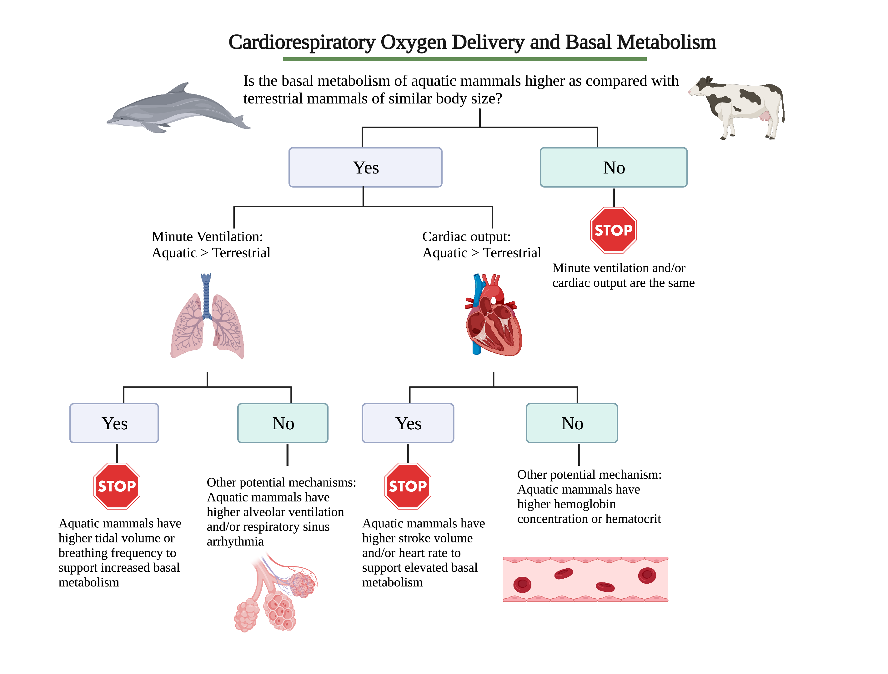

**Figure 2. A)** Basal metabolic rate (BMR, kcal • day-1), B) resting heart rate (beats • min-1), C) stroke volume (ml • beat-1), D) breathing frequency (breaths • min-1), E) tidal volume (ml • breath-1), and against body mass (kg) for terrestrial and aquatic mammals.The solid (terrestrial) and broken (aquatic) black lines are the prediction equations from the literature: A) BMR terrestrial = 70 • body mass0.75 (Kleiber, 1947), B) heart rate terrestrial = 241 • body mass-0.25 (Stahl, 1967), C) stroke volumeterrestrial = cardiac output • heart rate = [181 • body mass0.81] • [241 • body mass-0.25]-1 (Stahl, 1967), D) breathing frequency terrestrial = 53.5 • body mass-0.26 (Stahl, 1967), E) breathing frequency aquatic = 33 • body mass-0.42 (Mortola and Limoges, 2006), tidal volume terrestrial = 76.9 • body mass1.04 (Stahl, 1967) and tidal volume aquatic = 0.0372 • body mass0.92 (Fahlman et al., 2020a).

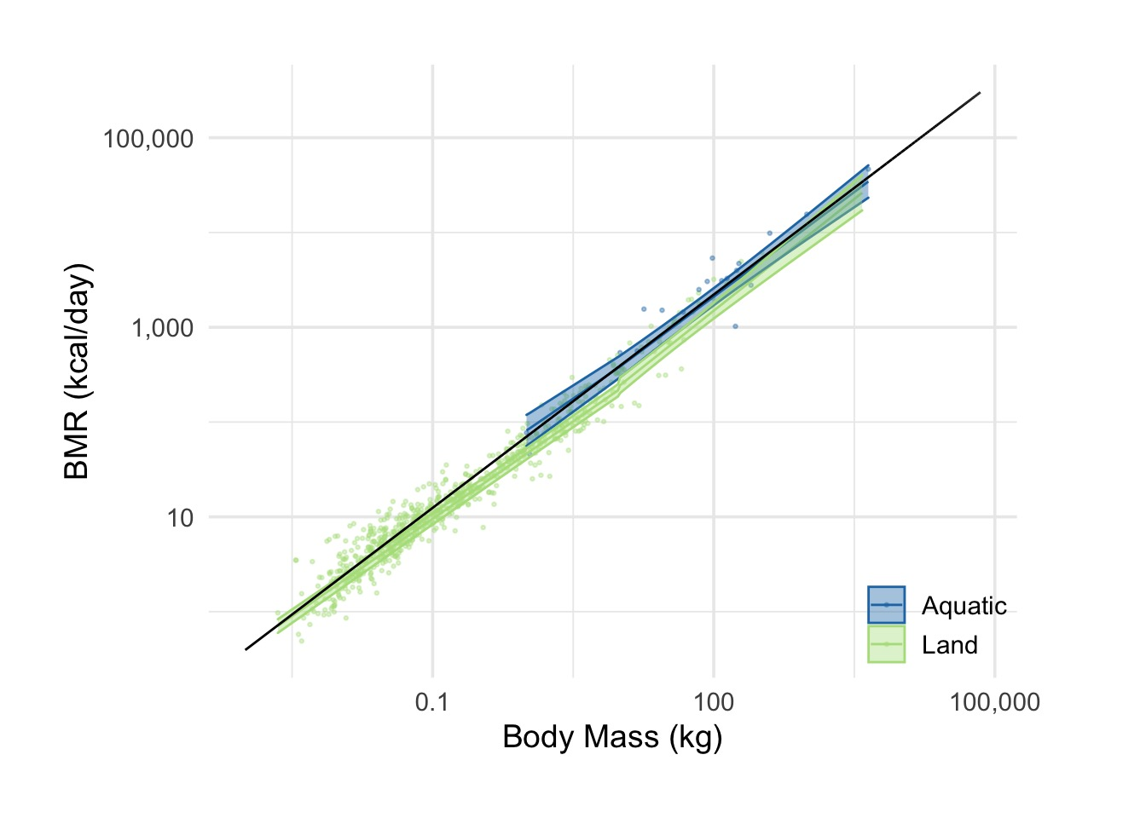

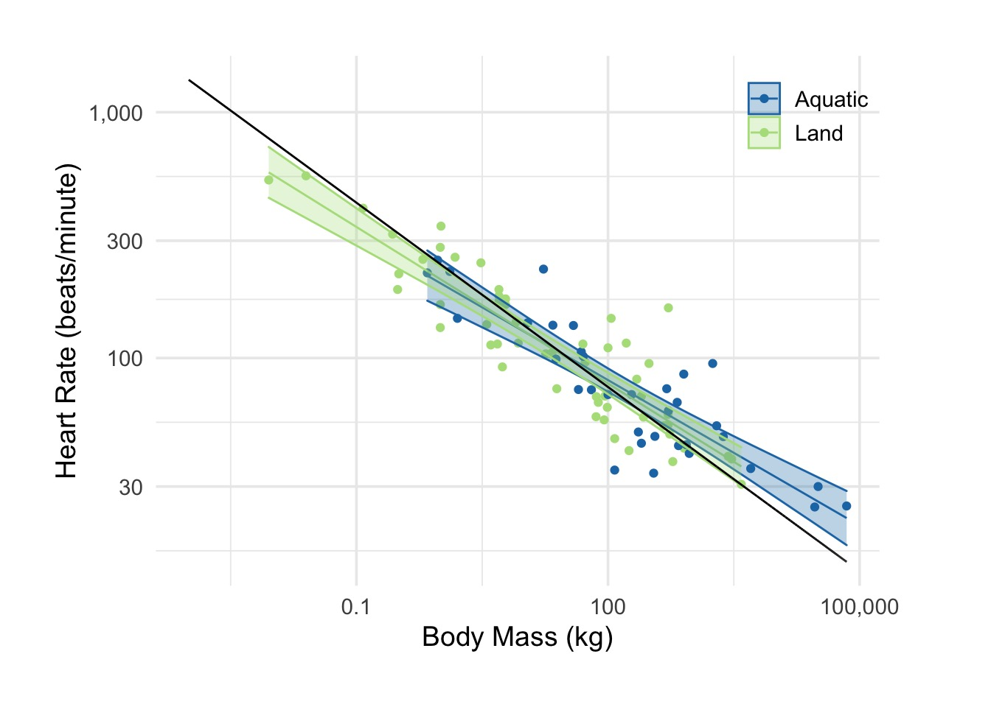

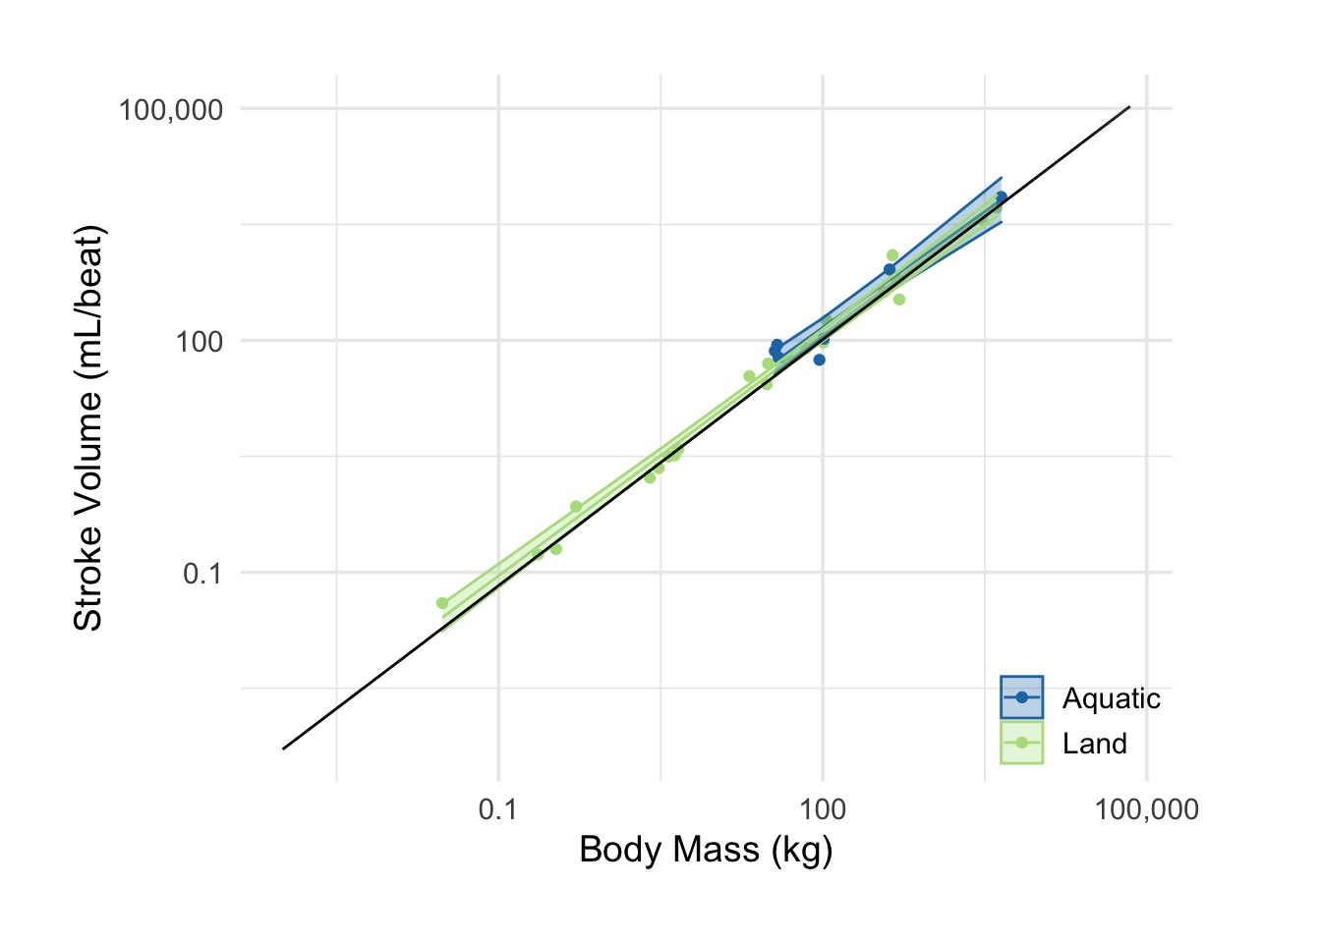

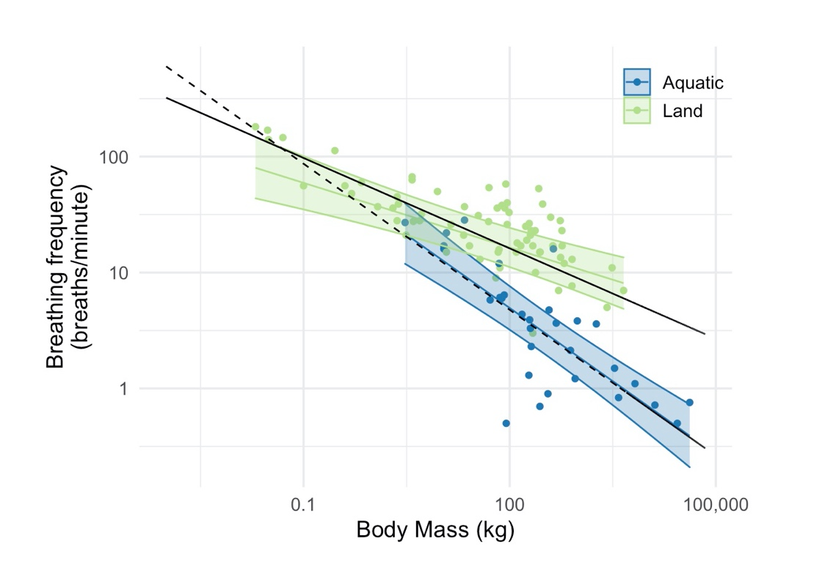

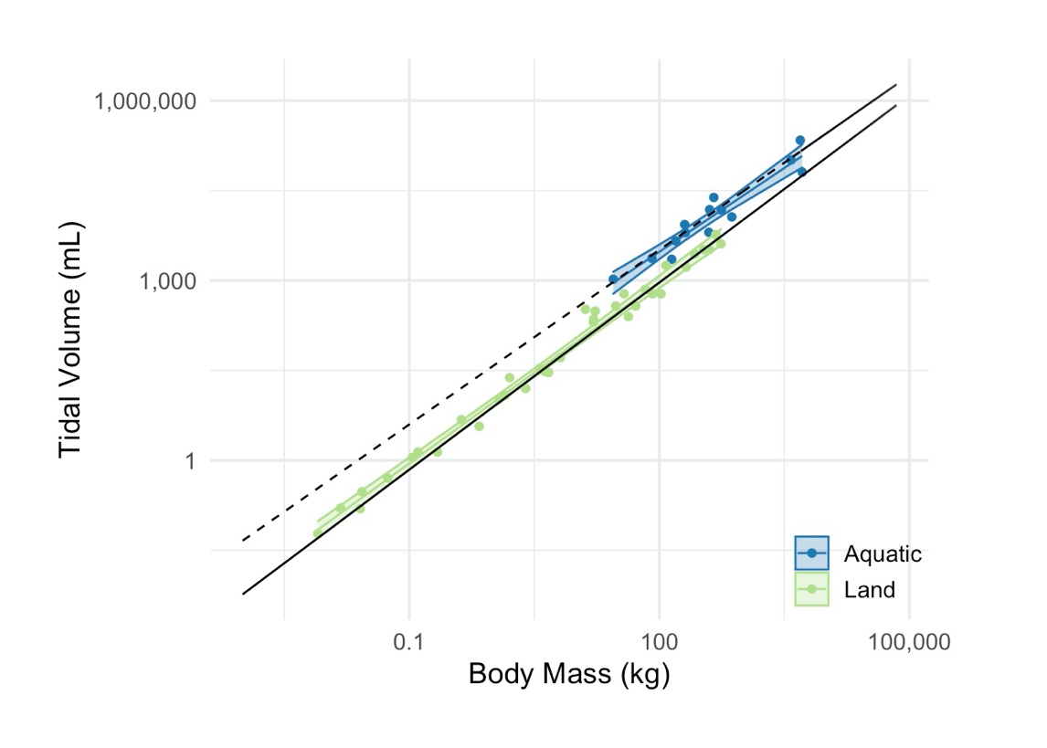

**Authors' contributions**

AF, and JAS conceived of the study. JAS, AB, and AF developed the hypothesis, RSH, and DLD obtained the historical data, RSH, SDR, TW, DLD, AS, BS, SD and AF analyzed the data. SDR, TW, AS, BS, and SD carried out the statistical analysis. RSH and AF and drafted the paper, with feedback from co-authors. All authors gave final approval for publication.

**Supplementary materials**

Please refer to this [link](https://stacyderuiter.github.io/mammal-allometry/) for supplementary materials.

**References**

Bates, D., Mächler, M., Bolker, B., Walker, S., 2015. Fitting Linear Mixed-Effects Models Using lme4. Journal of Statistical Software 67, 1 - 48.

Beechler, B.R., Jolles, A.E., Ezenwa, V.O., 2009. Evaluation of hemtaologic values in free-ranging African buffalo (*Syncerus caffer*). J Wild Dis 45, 57-66.

Ben-Tal, A., Shamailov, S.S., Paton, J.F.R., 2012. Evaluating the physiological significance of respiratory sinus arrhythmia: looking beyond ventilation–perfusion efficiency. J. Physiol. 590, 1989-2008.

Benedict, F.G., Ritzman, E.G., 1935. Lability of the Basal Metabolism of the Dairy Cow. Proc. Natl. Acad. Sci. USA 21, 304-308.

Blawas, A.M., Nowacek, D.P., Allen, A., Rocho-Levine, J., Fahlman, A., 2021a. Respiratory sinus arrhythmia and submersion bradycardia in bottlenose dolphins (*Tursiops truncatus*). J Exp Biol 224.

Blawas, A.M., Nowacek, D.P., Rocho-Levine, J., Robeck, T.R., Fahlman, A., 2021b. Scaling of heart rate with breathing frequency and body mass in cetaceans. Phil. Trans. Roy. Soc. Lond. B 376, 20200223.

Brooks, M.E., Kristensen, K., van Benthem, K.J., Magnusson, A., Berg, C.W., Nielsen, A., Skaug, H.J., Maechler, M., Bolker, B.M., 2017. glmmTMB Balances Speed and Flexibility Among Packages for Zero-inflated Generalized Linear Mixed Modeling. The R Journal 9, 378-400.

Cauture, F., SterbaBoatwright, B., Miedler, S., Rocho-Levine, J., Harms, C., Fahlman, A., 2019. Using Respiratory Sinus Arrhythmia to estimate inspired tidal volume in the bottlenose dolphin (*Tursiops truncatus*). Front. Physiol. 10.

Choy, E.S., Campbell, K.L., Berenbrink, M., Roth, J.D., Loseto, L.L., 2019. Body condition impacts blood and muscle oxygen storage capacity of free-living beluga whales (Delphinapterus leucas). J. Exp. Biol. 222.

Darveau, C.-A., Suarez, R.K., Andrews, R.D., Hochachka, P.W., 2002. Allometric cascade as a unifying principle of body mass effects on metabolism. Nature 417, 166-170.

Fahlman, A., Borque-Espinosa, A., Facchin, F., Ferrero Fernandez, D., Muñoz Caballero, P., Haulena, M., Rocho-Levine, J., 2020a. Comparative respiratory physiology in cetaceans. Front. Physiol. 11, 1-7.

Fahlman, A., Miedler, S., Marti-Bonmati, L., Ferrero Fernandez, D., Muñoz Caballero, P., Arenarez, J., Rocho-Levine, J., Robeck, T., Blawas, A.M., 2020b. Cardiorespiratory coupling in cetaceans; a physiological strategy to improve gas exchange? J. Exp. Biol. 223, jeb226365.

Fahlman, A., Miedler, S., Rocho-Levine, J., Jabois, A., Arenarez, J., Marti-Bonmati, L., García-Párraga, D., Cauture, F., 2019. Re-evaluating the significance of the dive response during voluntary surface apneas in the bottlenose dolphin, *Tursiops truncatus*. Sci. Rep. 9, 8613.

Fahlman, A., Moore, M.J., Garcia-Parraga, D., 2017. Respiratory function and mechanics in pinnipeds and cetaceans. J. Exp. Biol. 220, 1761-1763.

Gallivan, G.J., Ronald, K., 1979. Temperature regulation in freely diving harp seals (Phoca groenlandica). Can. J. Zool. 57, 2256-2263.

Genoud, M., Isler, K., Martin, R.D., 2018. Comparative analyses of basal rate of metabolism in mammals: data selection does matter. Biological Reviews 93, 404-438.

Hart, J.S., Irving, L., Mackenzie, B., 1959. THE ENERGETICS OF HARBOR SEALS IN AIR AND IN WATER WITH SPECIAL CONSIDERATION OF SEASONAL CHANGES. Can. J. Zool. 37, 447-457.

Hayano, J., Yasuma, F., Okada, A., Mukai, S., Fujinami, T., 1996. Respiratory Sinus Arrhythmia: A phenomenon improving pulmonary gas exchange and circulatory efficiency. Circulation 94, 842-847.

Irving, L., Hart, J.S., 1957. The metabolism and insulation of seals as bare-skinned mammals in cold water Can. J. Zool. 35, 497-511.

Irving, L., Scholander, P.F., Grinnell, S.W., 1941. Significance of the heart rate to the diving ability of seals. J. Cell. Comp. Physiol. 18, 283-297.

Irving, L., Solandt, O.M., Solandt, D.Y., Fisher, K.C., 1935. The respiratory metabolism of the seal and its adjustment to diving. J. Cell. Comp. Physiol. 7, 137-151.

Kanwisher, J., Sundness, G., 1965. Physiology of a small cetacean. Hval Skrift 48, 45-53.

Kanwisher, J.W., Ridgway, S.H., 1983. The physiological ecology of whales and porpoises. Sci. Am. 248, 110-120.

Killen, S.S., Glazier, D.S., Rezende, E.L., Clark, T.D., Atkinson, D., Willener, A.S., Halsey, L.G., 2016. Ecological Influences and Morphological Correlates of Resting and Maximal Metabolic Rates across Teleost Fish Species. The American naturalist 187, 592-606.

Kleiber, M., 1947. Body size and metabolic rate Physiol. Rev. 27, 511-541.

Kleiber, M., 1961. The Fire of Life: An Introduction to Animal Energetics. Wiley, New York.

Kolokotrones, T., Van, S., Deeds, E.J., Fontana, W., 2010. Curvature in metabolic scaling. Nature 464, 753-756.

Kooyman, G.L., 1973. Respiratory adaptations in marine mammals. Am. Zool. 13, 457-468.

Lavigne, D.M., Innes, S., Worthy, G.A.J., Kovacs, K.M., Schmitz, O.J., Hickie, J.P., 1986. Metabolic rate of seals and whales. Can. J. Zool. 64, 279-284.

McNab, B.K., 1988. Complications inherent in scaling the basal rate of metabolism in mammals. Quarterly Review of Biology 63, 25-54.

McNab, B.K., 2008. An analysis of the factors that influence the level and scaling of mammalian BMR. Comparative Biochemesitry and Physiology A 151, 5-28.

Mortola, J.P., 2015. The heart rate - breathing rate relationship in aquatic mammals: A comparative analysis with terrestrial species. Current Zoology 61, 569-577.

Mortola, J.P., Limoges, M.-J., 2006. Resting breathing frequency in aquatic mammals: A comparative analysis with terrestrial species. Resp. Physiol. Neurobiol. 154, 500-514.

Naya, D.E., Naya, H., White, C.R., 2018.

Data from: On the interplay among ambient temperature, basal metabolic rate and body mass

.

Pedersen, M.B., Fahlman, A., Borque-Espinosa, A., Madsen, P.T., Jensen, F.H., 2020. Whistling is metabolically cheap for communicating bottlenose dolphins (*Tursiops truncatus*). J Exp Biol 223, jeb.212498.

Pinheiro, J., Bates, D., DebRoy, S., Sarkar, D., 2021. nlme: Linear and Nonlinear Mixed Effects Models. R package version 3, R Core Team 1-152.

Piscitelli, M.A., Raverty, S.A., Lillie, M.A., Shadwick, R.E., 2013. A review of cetacean lung morphology and mechanics. J. Morphol. 274, 1425-1440.

Plotka, E.D., Eagle, T.C., Gaulke, S.J., Tester, J.R., Siniff, D.B., 1988. Hematologic and blood chemical characteristics of feral horses from three management areas. J Wildl Dis 24, 231-239.

Rosen, D.A.S., Trites, A.W., 2013. Resting Metabolic Rate of a Mature Male Beluga Whale (*Delphinapterus leucas*). Aquat Mam 39, 85-88.

Rosen, D.A.S., Trites, A.W., 2014. Thermal limits in young northern fur seals, Callorhinus ursinus. Mar. Mam. Sci. 30, 1014-1028.

Rubner, M., 1865. Ueber den Einfluss der Körpergrösse auf Stoff- und Kraftwechsel. Zeitschrift für Biologie 19, 535-562.

Rusoff, L.L., Frye Jr, J.B., Scott Jr, G.W., 1951. Blood studies of red Sindhi-Jersey crosses. I. Hemoglobinm, hematocrit, plasma calcium, and plasma inorganic phosphorus values of red Sindhi-Hersey daughters and their Jersey dams. Journal of Dairy Science 34, 1145-1150.

Schmitz, O.J., Lavigne, D.M., 1984. Intrinsic Rate of Increase, Body Size, and Specific Metabolic Rate in Marine Mammals. Oecologia 62, 305-309.

Scholander, P.F., 1940. Experimental investigations on the respiratory function in diving mammals and birds. Hvalrådets Skrifter 22, 1-131.

Scholander, P.F., Irving, L., Grinnell, S.W., 1942. On the temperature and metabolism of the seal during diving. J. Cell. Comp. Physiol. 19, 67-78.

Scholander, P.F., Walters, V., Hock, R., Irving, L., 1950. Body insulation of some arctic and tropical mammals and birds. Biol Bull 99, 225-236.

Sergeant, D.E., 1973. Biology of white whales (*Delphinapterus leucas*) in western Hudson bay. Journal of Fisheries Research Board Canada 30, 1065-1090.

Snyder, G.K., 1983. Respiratory adaptations in diving mammals. Respiration Physiology 54, 269-294.

South, F.E., Luecke, R.H., Zatzman, M.L., Shanklin, M.D., 1976. Air temperature and direct partitional calorimetry of the California sea lion (Zalophus Californianus). Comparative Biochemistry and Physiology Part A: Physiology 54, 27-30.

Speakman, J.R., Król, E., 2010. Maximal heat dissipation capacity and hyperthermia risk: neglected key factors in the ecology of endotherms. Journal of Animal Ecology 79, 726-746.

Speakman, J.R., Król, E., Johnson, M.S., 2004. The Functional Significance of Individual Variation in Basal Metabolic Rate. Physiol. Biochem. Zool. 77, 900-915.

Stahl, W.R., 1967. Scaling of respiratory variables in mammals. J. Appl. Physiol. 22, 453-460.

Upham, N.S., Esselstyn, J.A., Jetz, W., 2019. Inferring the mammal tree: Species-level sets of phylogenies for questions in ecology, evolution, and conservation. PLOS Biology 17, e3000494.

Vestweber, J.G., Johnson, D.E., Merrill, G.L., Staats, J.J., 1991. Hematological and blood chemistry profiles of American bison grazing on Konza Prairie of Kansas. J Wildl Dis 27, 417-420.

West, G.B., Brown, J.H., Enquist, B.J., 1997. A General Model for the Origin of Allometric Scaling Laws in Biology. Sci. 276, 122-126.

West, G.B., Woodruff, W.H., Brown, J.H., 2002. Allometric scaling of metabolic rate from molecules and mitochondria to cells and mammals. Proc. Natl. Acad. Sci. USA 99 Suppl 1, 2473-2478.

West, J.B., 2012. Respiratory Physiology, 9th ed. Wolters Kluwer-Lippincott Williams & Wilkins, Philadelphia.

White, C.R., 2010. There is no single p. Nature 464, 691-693.

White, C.R., Seymour, R.S., 2003. Mammalian basal metabolic rate is proportional to body mass 2/3. Proceedings of the Natliona Academy of Science U S A 100, 4046-4049.

White, C.R., Seymour, R.S., 2005. Allometric scaling of mammalian metabolism. J. Exp. Biol. 208, 1611-1619.

Williams, T.M., Haun, J., Davis, R.W., Fuiman, L.A., Kohin, S., 2001. A killer appetite: metabolic consequences of carnivory in marine mammals. Comp. Biochem. Physiol. A. 129, 785-796.

Worthy, G.A.J., Worthy, T.A.M., Yochem, P.K., Dold, C., 2013. Basal metabolism of an adult male killer whale (*Orcinus orca*). Mar. Mam. Sci. 30, 1229-1237.